AnalystLab Africa — Machine Learning Internship
Week 1–2 Summary Report: Data Preprocessing & Exploratory Data Analysis
Datasets: Titanic Dataset, Iris Dataset

1. Overview
This report summarizes the data preprocessing and exploratory data analysis (EDA) performed on the Titanic and Iris datasets during Week 1–2 of the Internship program. It covers the preprocessing decisions made, key visualizations produced, correlation analysis, insights discovered and an assessment of each dataset's readiness for machine learning model development.

2. Data Preprocessing Decisions

2.1 Titanic Dataset
- Missing values: Age was imputed using the median, chosen because it is robust to the column's skewed distribution and outliers. Embarked was imputed using the mode, since it is a categorical variable and the mode preserves the most common representative value. Cabin was dropped entirely, as the majority of its values were missing, making imputation not a valid option.
- Duplicates: The dataset was checked for duplicate records; none were found, so no rows were removed.
- Outliers: Boxplots and the IQR method were used to inspect Age and Fare. Fare showed a long right tail of high-value fares and was capped at the 95th percentile to reduce its influence on scaled/distance-based models, without discarding the underlying records. Age outliers (a small number of older passengers) were retained, since these are plausible, legitimate values rather than data errors.
- Encoding: Sex and Embarked were converted using One-Hot Encoding (with the first category dropped to avoid redundancy), producing binary numerical columns suitable for modeling.
- Scaling: Age and Fare were scaled using StandardScaler, transforming both to a mean of 0 and standard deviation of 1.

2.2 Iris Dataset
- Missing values: None were found in the Iris dataset, so no imputation was necessary.
- Duplicates: The dataset was checked for duplicate records; none were found.
- Outliers: Boxplots and the IQR method were used to inspect all four measurement columns. A small number of points (e.g., in Sepal Width) fell outside the IQR whiskers, but since Iris is a small, well-curated dataset, these were judged to reflect genuine natural variation between species rather than measurement error, and were retained.
- Encoding: The target column, Species, was converted from text labels (Iris-setosa, Iris-versicolor, Iris-virginica) to numerical values (0, 1, 2) using Label Encoding.
- Scaling: All four numerical measurement columns (Sepal Length, Sepal Width, Petal Length, Petal Width) were scaled using StandardScaler.

3. Key Visualizations
The following visualizations were produced during EDA.

3.1 Titanic
Fare and Age distribution showing the skewness on both columns.

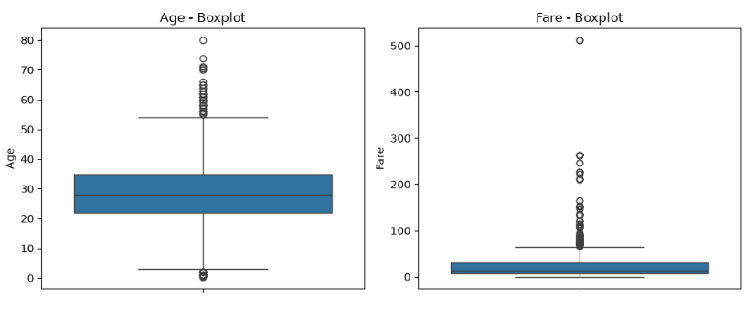
Histogram Showing Passennger Fare distribution on the Titanic dataset.

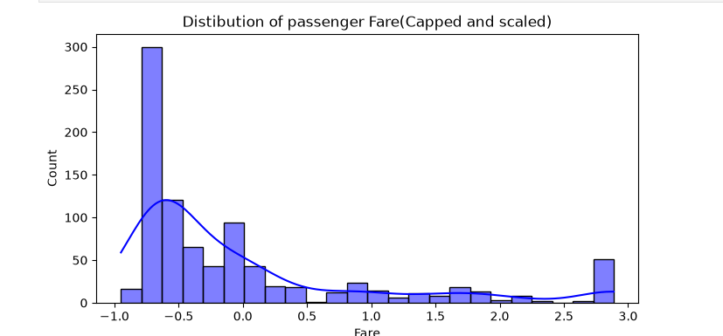

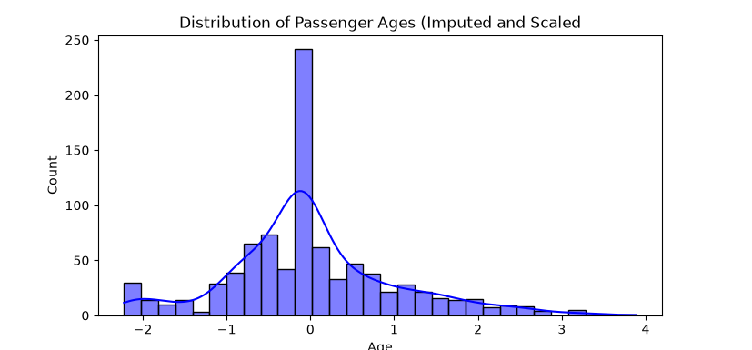

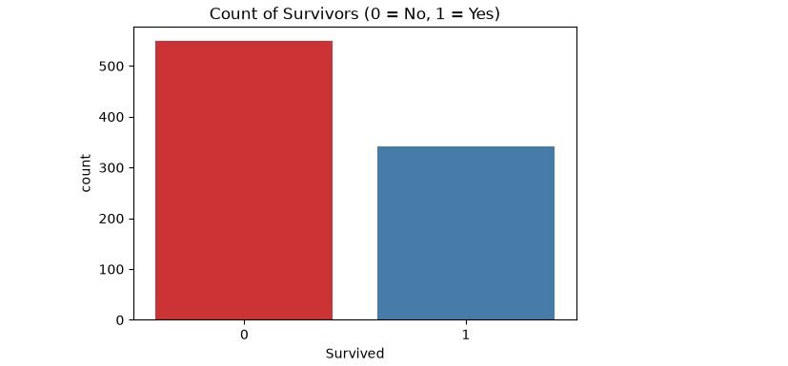
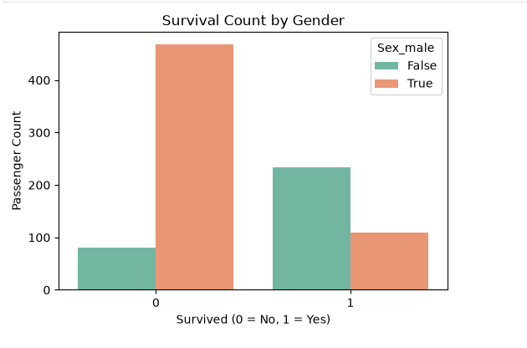

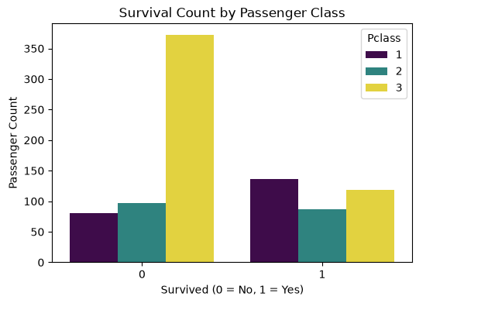
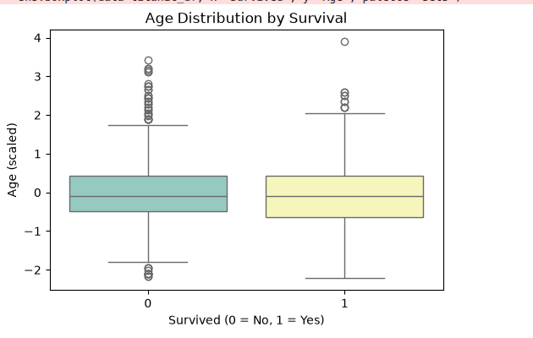
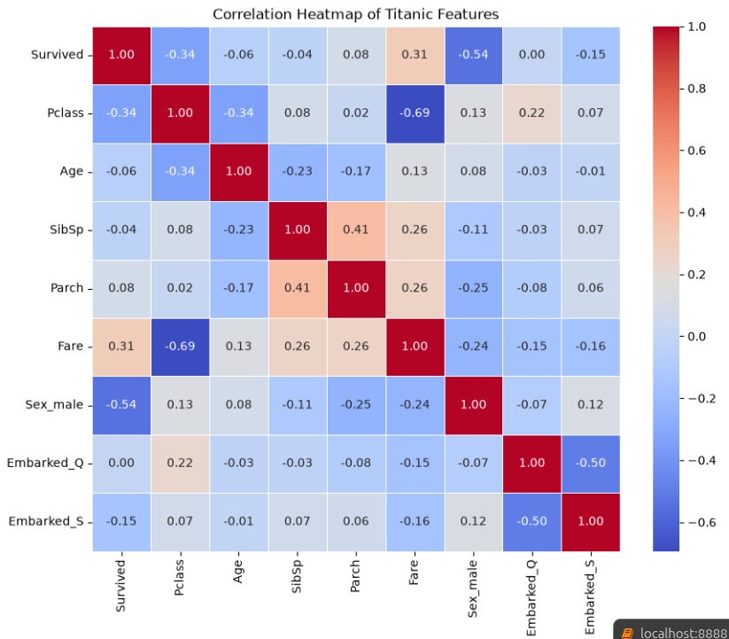

3.2 Iris
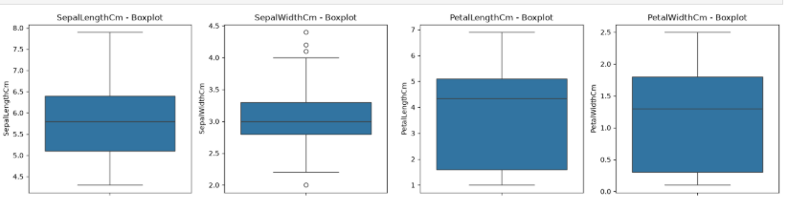
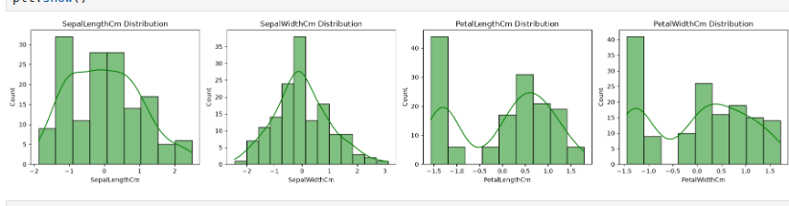
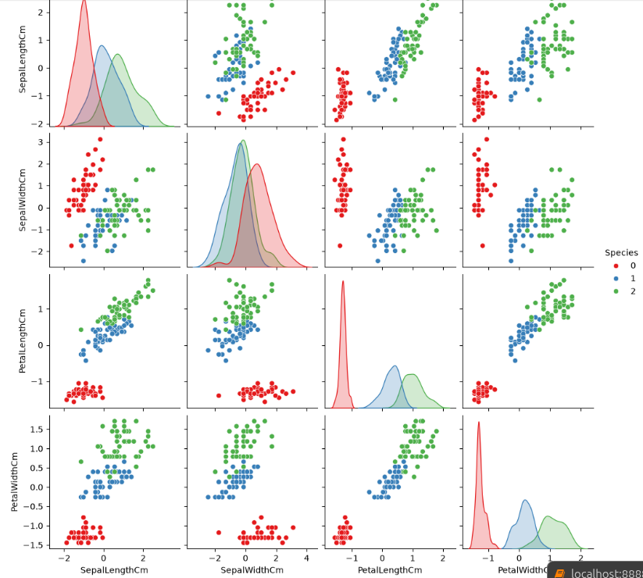
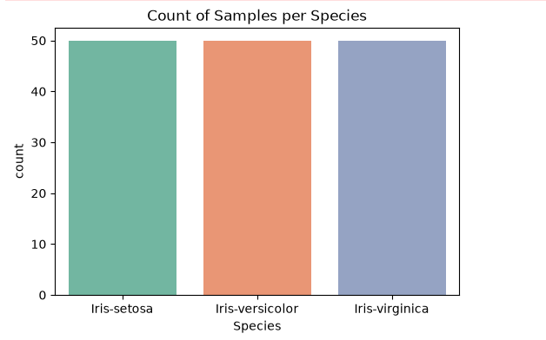
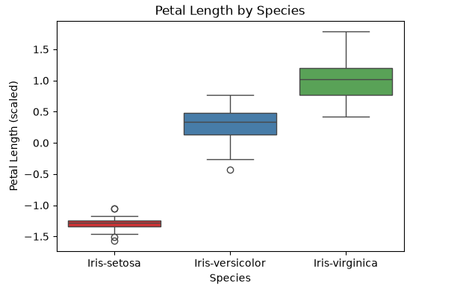
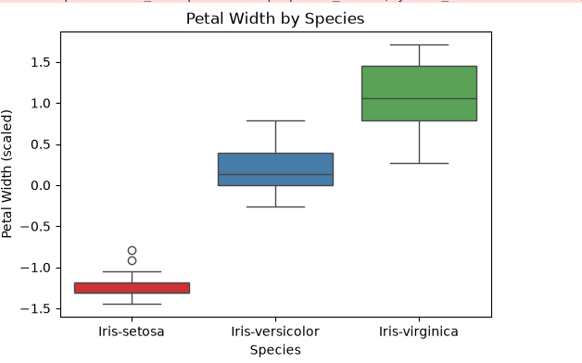
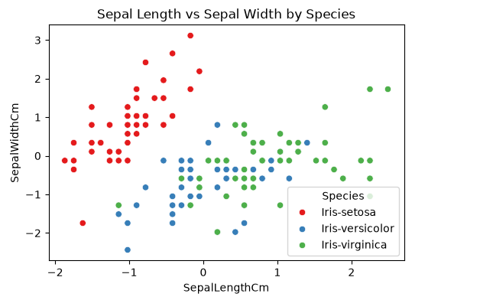
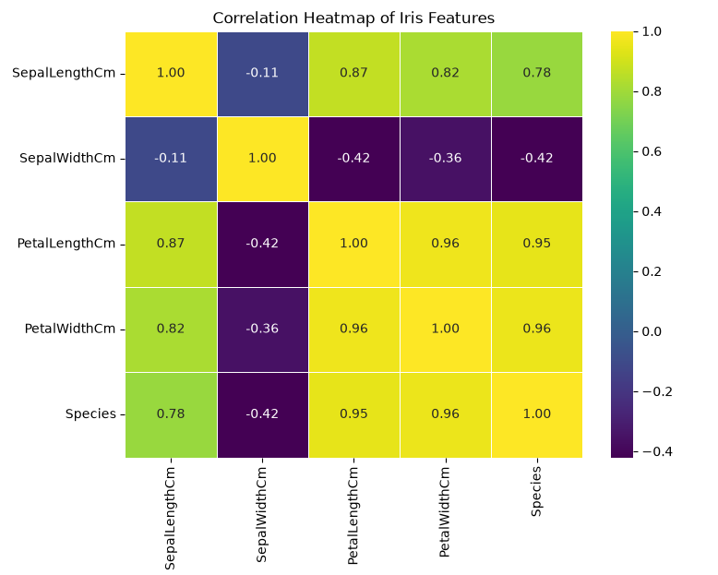

4. Correlation Analysis

4.1 Titanic
A correlation matrix and heatmap were generated across the numerical and encoded features. The strongest correlations with the target variable, Survived, come from Gender (Sex_male), Passenger Class (Pclass), and Fare these are the features most likely to be useful for a predictive model. No feature pairs showed a strong enough correlation with each other to be flagged as redundant.

4.2 Iris
A correlation matrix and heatmap were generated across the four measurement columns and the Species target. Petal Length and Petal Width are strongly correlated with Species and with each other — this pair is a classic case of redundant features, since they carry very similar information, and a model could likely rely on just one with little loss of accuracy. Sepal Width is the weakest correlate with Species. Overall, petal measurements are far more useful for distinguishing species than sepal measurements.

5. Key Insights

5.1 Titanic — Insights
- Fare is highly right skewed, most passengers paid low fairs
- Comparing gender column to the survival target, more females survived compared to males
- Third class passengers did not survive as often as compared to first class passengers
- Passengers who embarked at Cherbourg (Embarked = C) had a noticeably higher survival rate than those who boarded at Southampton or Queenstown, likely linked to a higher share of first-class passengers embarking there.
- Fare and Passenger Class are closely linked - higher fares are strongly associated with 1st class tickets, and both individually correlate with a higher chance of survival.
- Younger passengers (children) had a somewhat higher survival rate than adults, consistent with the 'women and children first' evacuation priority reflected in the data.

5.2 Iris — Insights
- Petal Length and Petal Width are the most discriminating features for classifying species - Iris-setosa is almost perfectly separable from the other two species using these two measurements alone.
- Iris-setosa consistently has the smallest petal length and petal width but the largest sepal width of the three species, making it the easiest species to distinguish.
- Iris-versicolor and Iris-virginica overlap considerably on sepal length and sepal width, making these two features unreliable on their own for separating those two species.
- Petal Length and Petal Width are very strongly correlated with each other, confirming they carry largely redundant information for modeling purposes.
- Sepal Width shows the weakest relationship with Species of all four features, making it the least useful predictor in this dataset.
- Overall, the Iris dataset is highly separable by species when petal measurements are used, which explains why simple classifiers tend to perform very well on it.

6. Machine Learning Readiness Summary
Both datasets have been cleaned, transformed, and prepared for machine learning model development:
- Missing values: Titanic — Age (median), Embarked (mode), Cabin (dropped). Iris — none present.
- Duplicates: Checked in both datasets; none found.
- Outliers: Titanic — Fare capped at the 95th percentile; Age retained. Iris — all values retained as genuine natural variation.
- Encoding: Titanic — Sex and Embarked One-Hot Encoded. Iris — Species Label Encoded.
- Scaling: StandardScaler applied to Age and Fare (Titanic) and to all four measurement columns (Iris).
- Likely important features: Titanic — Gender, Passenger Class, and Fare. Iris — Petal Length and Petal Width.

Both the Titanic and Iris datasets are now clean, numerically encoded, and appropriately scaled, and are ready for model development in subsequent weeks of the internship.

